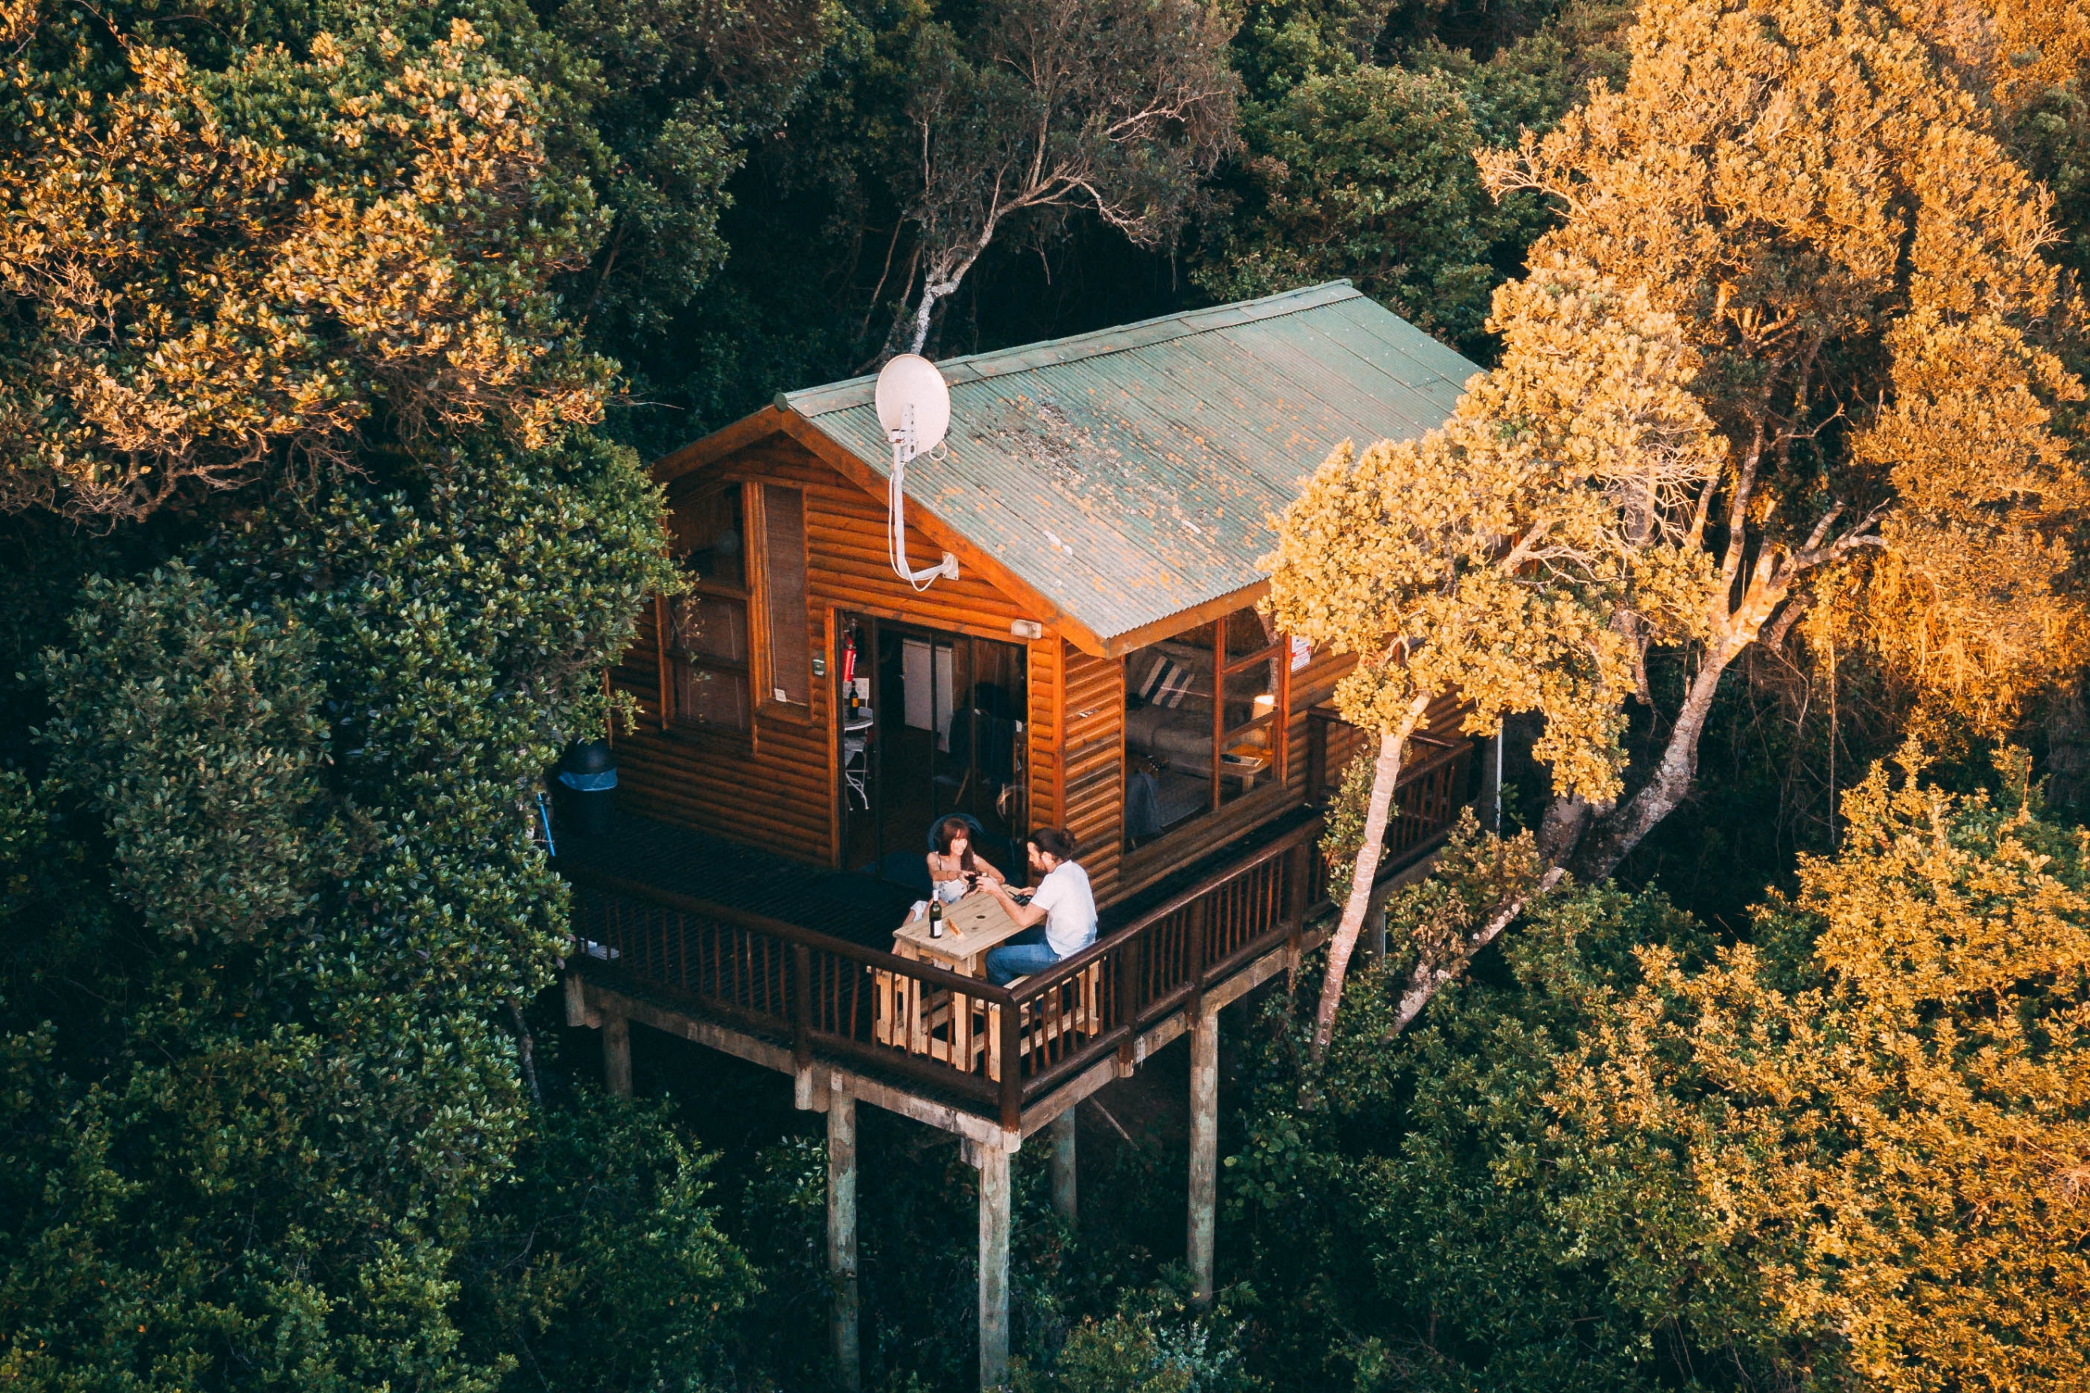

Design Report

# Website Design & Implementation Assessment

Introduction to Web Design (DECO1400)  
Semester 1, 2020

## By Minh Tuan TRAN (45604052)

Part A

# Introducing the Design Report

This design report reflects on the journey of website design and implementation which is an apart of the course DECO1400, Introduction to Web Design. The ‘client’ for this website design are the tutors from the course, who will eventually give mark for this report and its implementation on the website design. In this report, design concepts and the implementation of them will be covered.

For the concepts of creating website, many aspects will be taken into consideration. Organisation, navigation, aesthetic and technical implementation and their applications are main contents that will be discussed. Throughout the report, all the concepts will be implemented to the website design and the result will be at the end of the report.

# Introducing the Web Designer

A brief introduction about myself, this report’s author. I am a student studying undergraduate at University of Queensland, taking the Computer Science major. I’m taking the course DECO1400 to enhance my design thinking skills as I believe that this is important skills for working in technology industry.

I am confident that I have some prior knowledge for code to design a website. My learning strategy is to improve my designing skills. While revisiting coding skills for creating website, I also learn new concepts, get into good habits of coding and designing. I wish to cultivate more my coding skills and learn more about designing concepts to make my website more unique and creative.

After this course, I hope that I will have knowledge to make my own website. As I learning to create a website, I will understand and know how to collaborate well with partners in a big project that contain making website. Moreover, I can also create my own portfolio website that can showcase my accomplishments with employers. I believe Web Design is a good course that will contribute tremendously for my goal of becoming one of the best people in the technology industry.

 Responding

to the Brief

# Introducing the Website Topic

This report presents website design for hotels and resorts company at Amazon Rainforest. It is a website for showcase activities and moments at Amazon resort and offer booking deals for membership.

Originally, my website idea was to make a resort for people who love comic like Marvel or DC. The website would take a comic theme, decorated with superheroes pictures, and activities would be related to superheroes’ or villains’ stories that are famous to comic fans. This will attract a lot of people at the ages of teenager and adolescent.

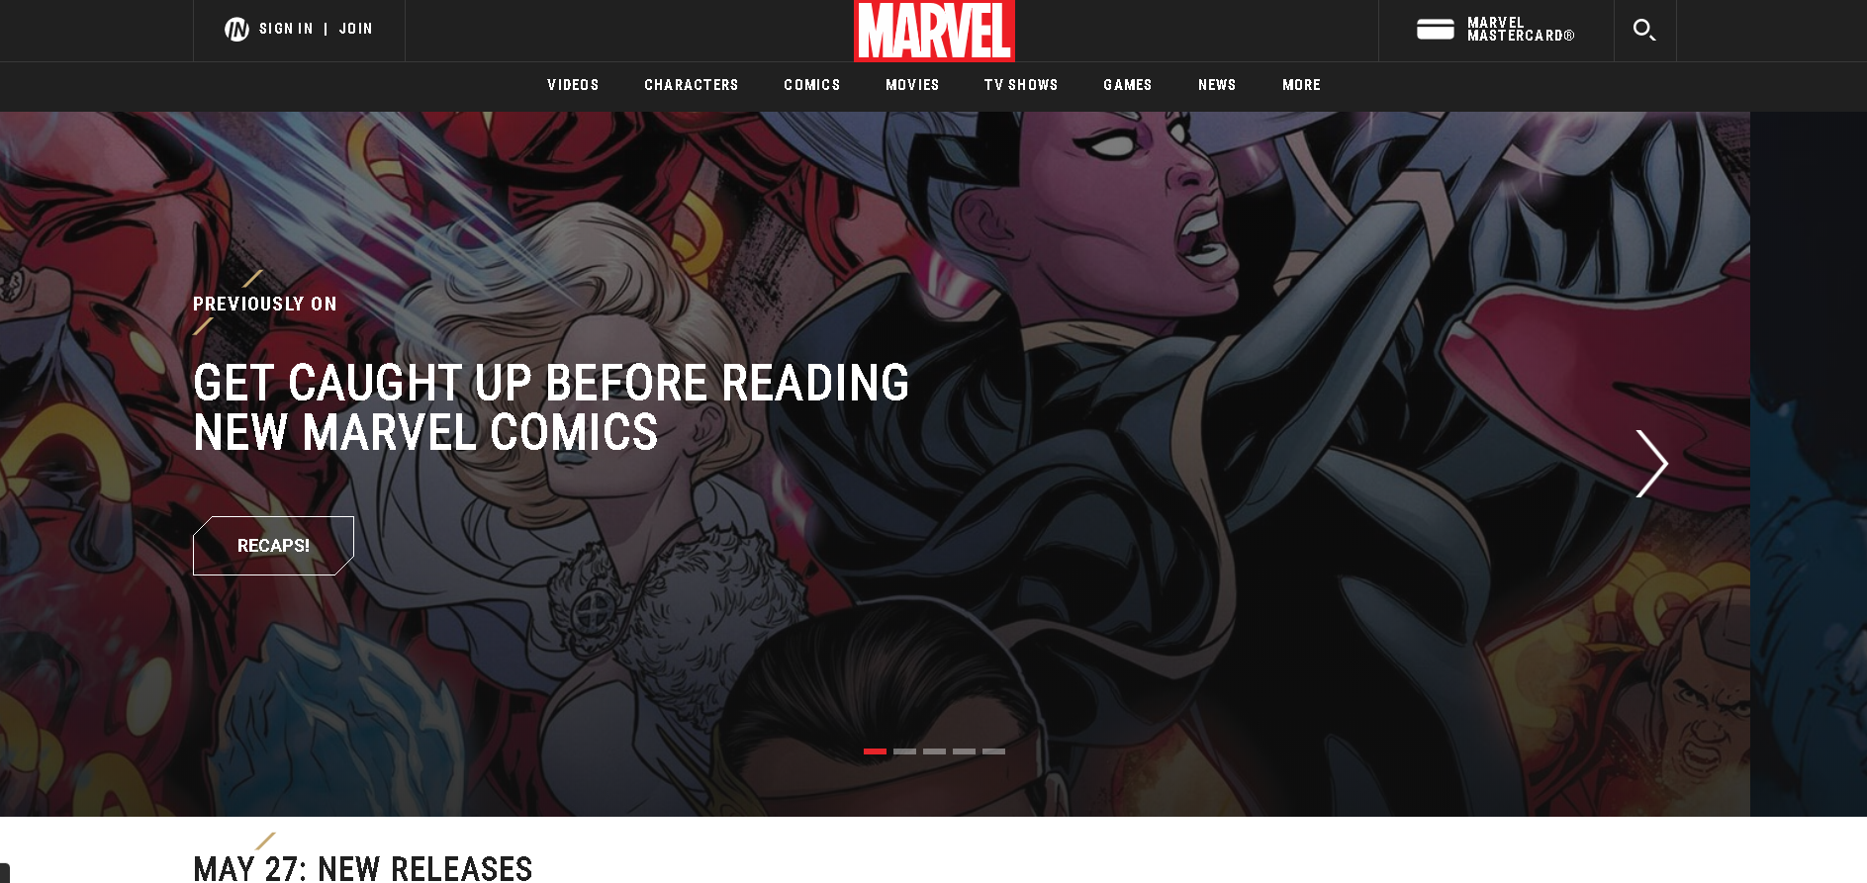

Marvel comic (n.d.)

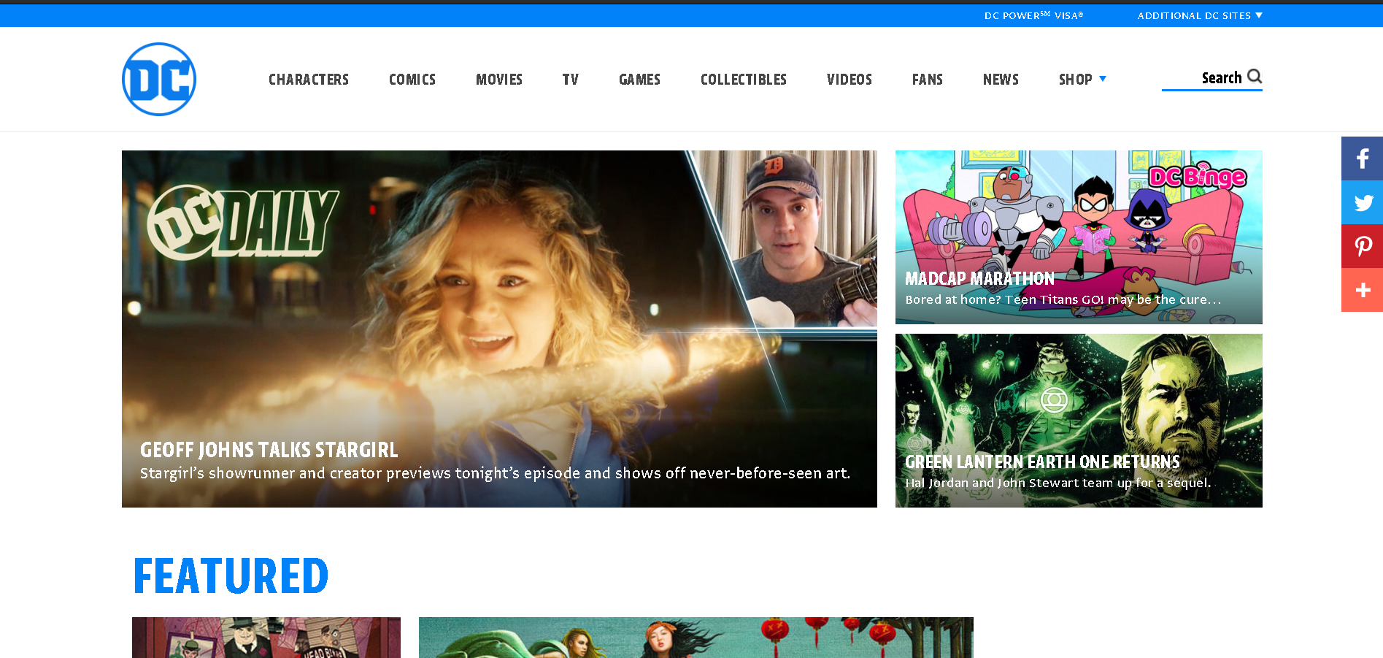

DC comic (n.d.)

However, I wanted my website to be something more fun and enjoyable. Because I love traveling, I decided to make a website for traveling with a lot of fun activities. As I was surfing the internet for an idea, I found a website which is very interesting, Lizard Island (Lizard Island, n.d.).

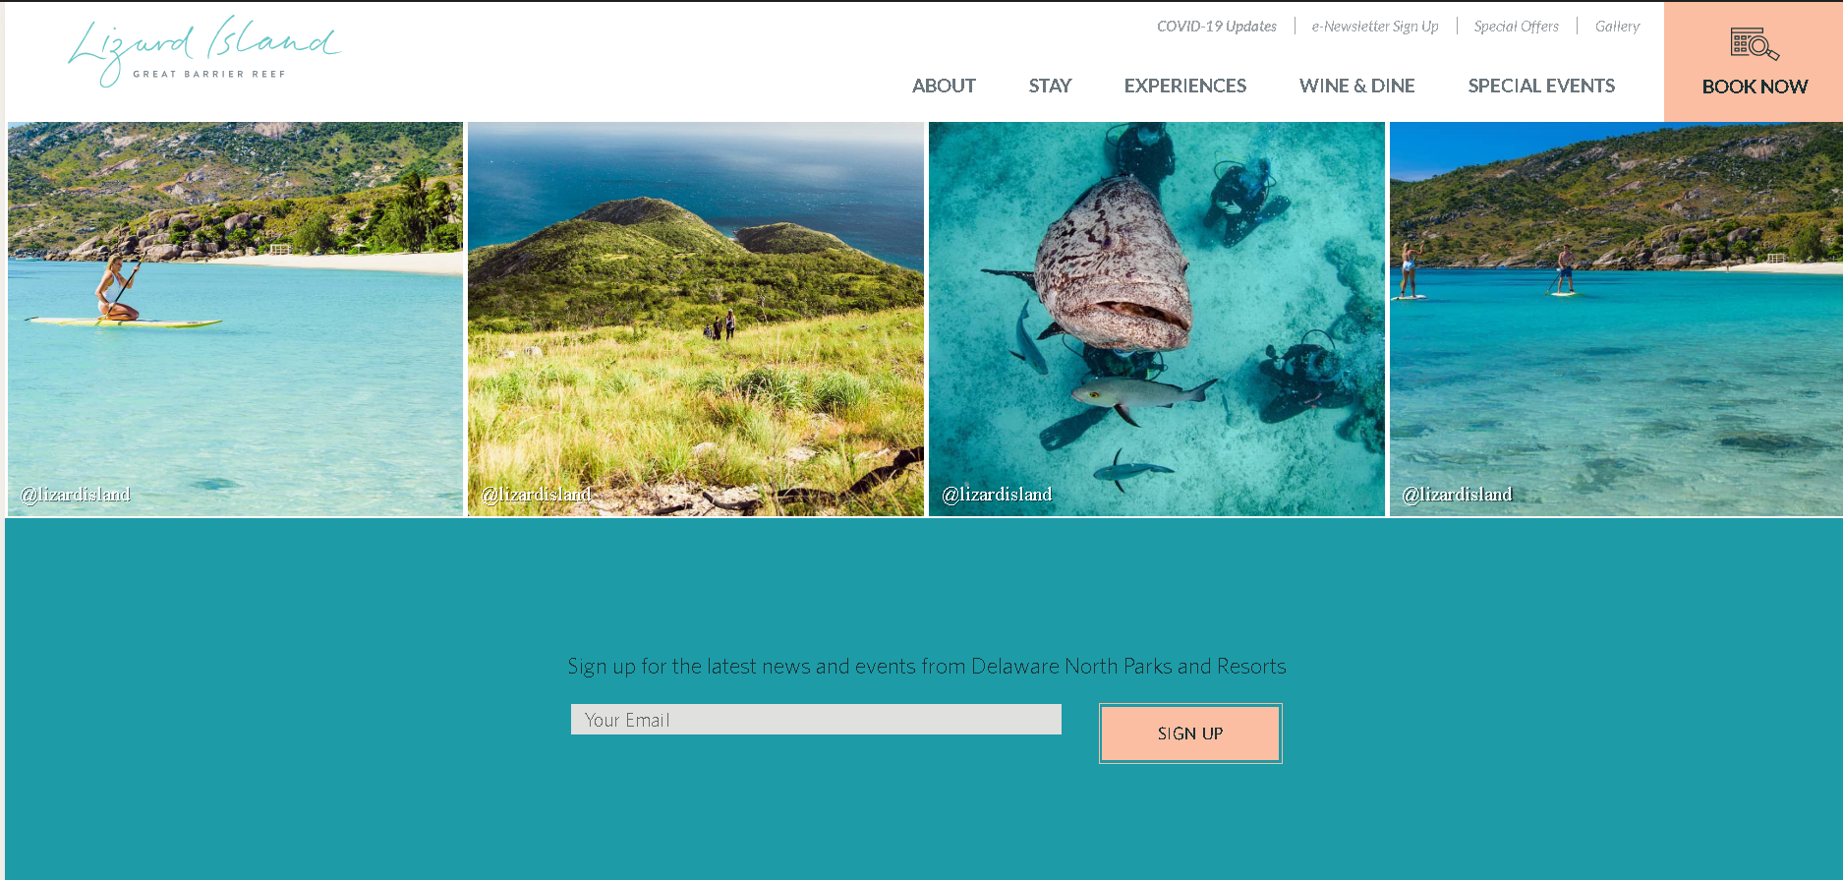

This is website presenting luxury stay at Lizard Island. This resort provide accommodation above the trees where customers can enjoy the beautiful view of the nature and the fresh atmosphere at the place. The resort brings to client relaxing time as well as exploring adventures in the ocean. The idea of the Lizard Island inspired this website idea with natural colours and adventurous activities. Therefore, I came up with website about resort at Amazon rainforest. While Lizard Island take blue as color scheme as this is color of ocean, my website will have a color scheme of green, which is forest color.

My target audience is from age group 18 to 25. From my perspective, people from this age group often like to travel and explore. They love adventure and play with animal, which is why I think this will be the perfect age group that my website would target to, since the website is about the life in nature where there are many things are waiting to be explored.

There are also people who would like to travel with family. Hence, the website will be implemented for an actual wider age range. There may be site for children and elders as well.

There are a wide range of activities and services at Amazon rainforest resort clients can enjoy. Visitors can play with friendly and well-trained sloths or riding crocodiles. There is variety of competitions. For example, visitors can have climbing competition with local monkeys in the forest or catching animal competition in special zone of the resort. The food in Amazon is also worth trying. There will be crocodile meat, piranha meat and many more.

As this is a resort, there are accommodation as well. Customer can choose one of Appartment, Tree house and Villa which all have their interesting features. In spite of living in the middle of the rainforest, facilities and utilities are also fully offered. Therefore, customers can have a full experience and a lot of fun at Amazon resort.

# Introducing the Target Audience

We have two users to consider.

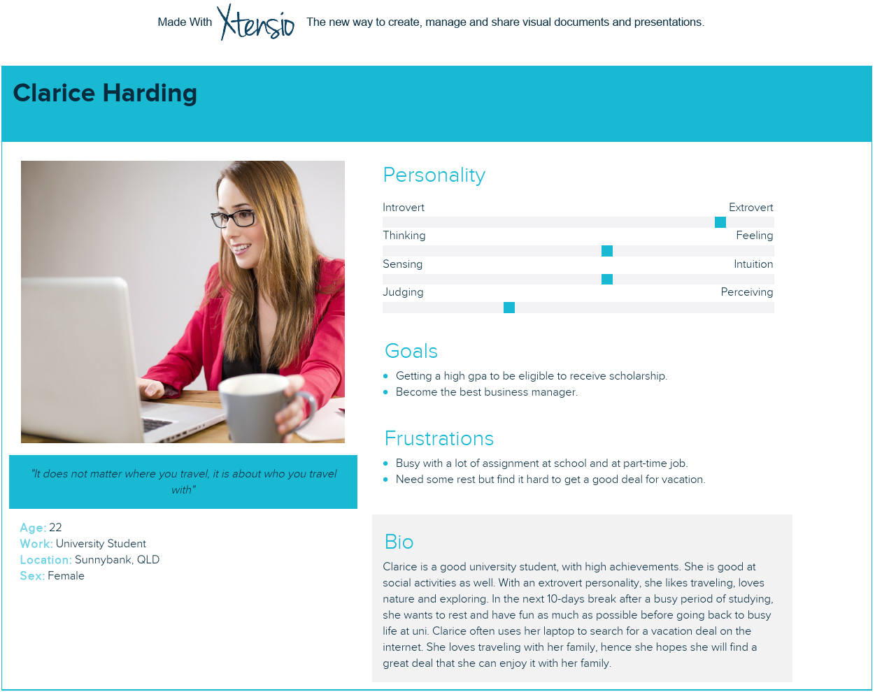

Tools: Xtensio (n.d.)

First user is Clarice, an university student. She likes traveling and loves nature, hence the website’s content should attract her. Since Clarice like travel deals, and she also likes travel with her family, it is worth to add a family deal for the website. To increase customer’s loyalty, there would be more great deal for memberships. Moreover, this vacation is for Clarice to reduce stress after a busy semester. Hence, the website should not have too much words, as words might remind students of assignments. Therefore, it is decided that the website content will be illustrated by using image to with just enough amount of words to support. With a lot of activities for exploring the nature and having fun with family, this will attract many people like Clarice to use website’s services.

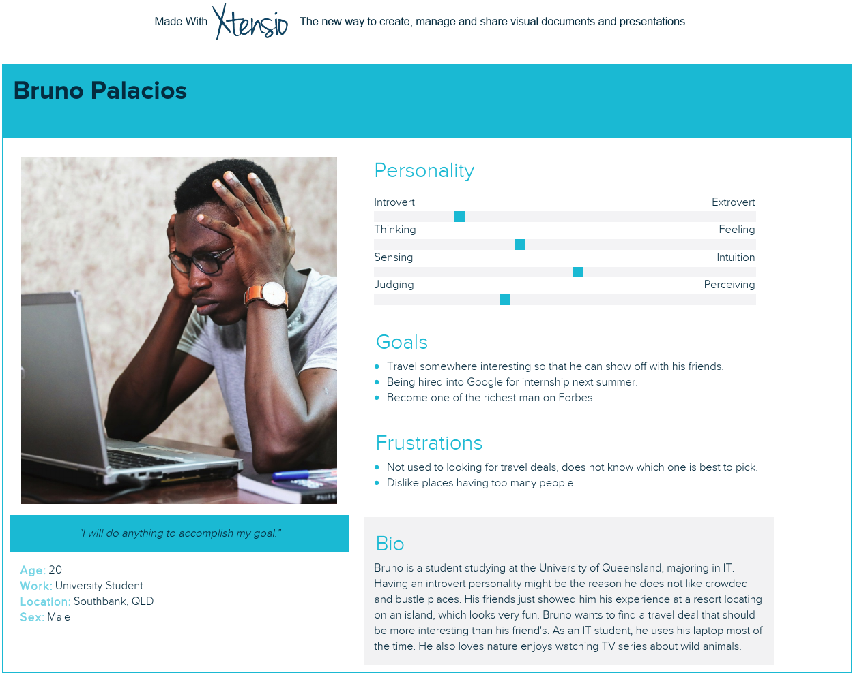

Tools: Xtensio (n.d.)

Another user is Bruno, he is an IT prodigy. In contrast of Clarice, Bruno has an introvert personality. He likes enjoying in a piece place, where there are not many people. Therefore, he might like some exploring activity like rowing on a peaceful river or travel under the water by submarine. Bruno wants to show off with his friends about his journey, there should be a lot of activities so that he can enjoy and save the moments. The food will be important as well, as he would have a full experience to be able to show his friends. Bruno likes wild animal, therefore, an activity that allow customer to play with the local sloths will be added. More deal should also be presented as Bruno is not so used to finding a vacation. This will definitely draw his attention and after the vacation, he will have lots of moments to share with his friends.

To sum up, the website will contain a lot of activities for exploring and food that customer can enjoy. There will be membership deals, which will attract people looking for a great, affordable price, especially for students. The colour scheme shall be green as this website is about resort at Amazon rainforest. Pictures and icons will be focused more than long paragraphs so the user may feel comfortable to scan through the website. As our two users are student and use their laptop a lot. This website will be implemented desktop-first approach which will focus on laptop users. Since Clarice is an outdoor person, she should be using her smart phone often as well. Therefore, designs for other devices like smartphone or tablet will also be implemented.

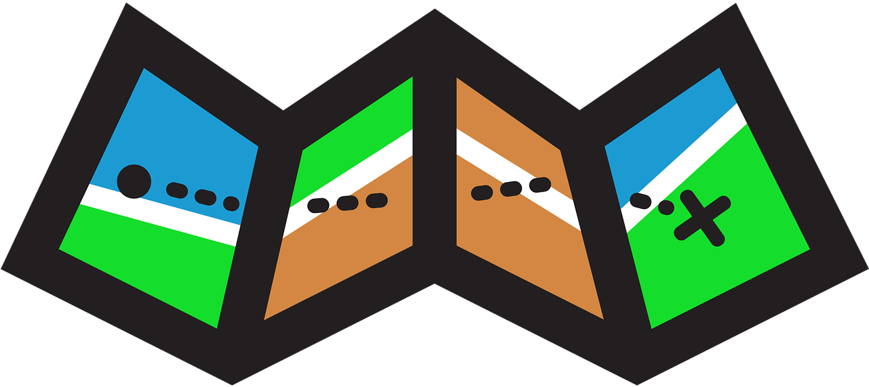Navigation & Organisation

# Card Sort User Testing

A testing plan was prepared for the Card Sorting activity. A total of 37 cards representing things that will appear or activities that user will be doing on the website.

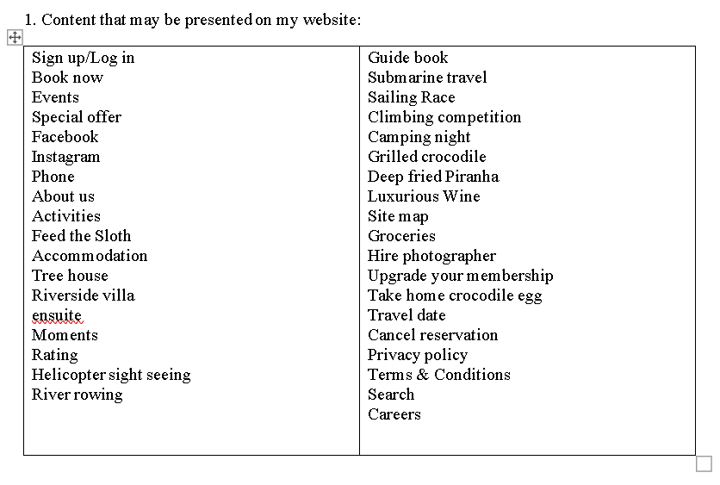

A card sort board then was created on the website Trello (n.d.) for easier moving the cards around and grouping them.

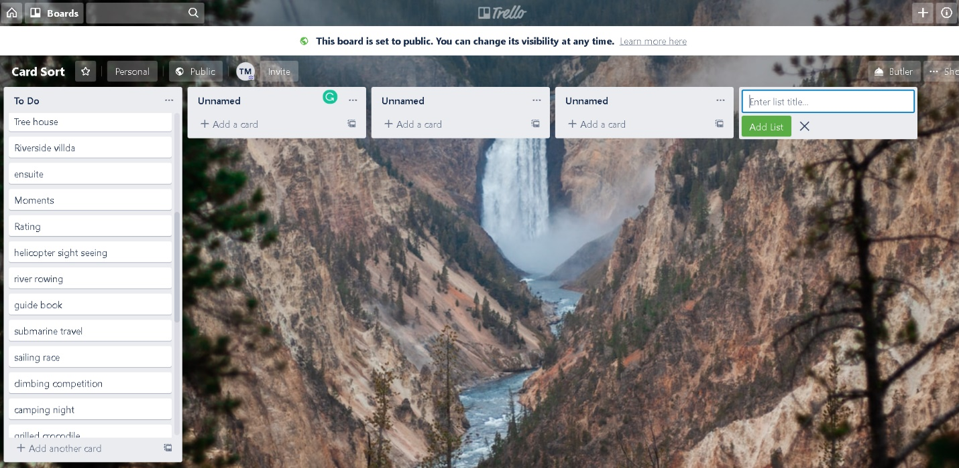

In this card sorting activity, I decided to run an open card sorting. The cards given were grouped by the ‘users’ and then named with convincing explanation. This is to approach what users may prefer about the content and the naming for the sections. Moreover, the ‘users’ joining in the activities are also in the target age group of this design project. Hence, it is a good idea to let the participants name the group themselves as this might result attracting more people in the target age group.

There were two participants who completed sorting the card. Both two ‘users’ had convincing way of grouping the items and there were also some things in common in the way they sorted the cards.

The first person grouped the cards into 7 different sections which are: Booking, Accommodations, Activities, Activities – Food, Contact detail and two other unnamed groups.

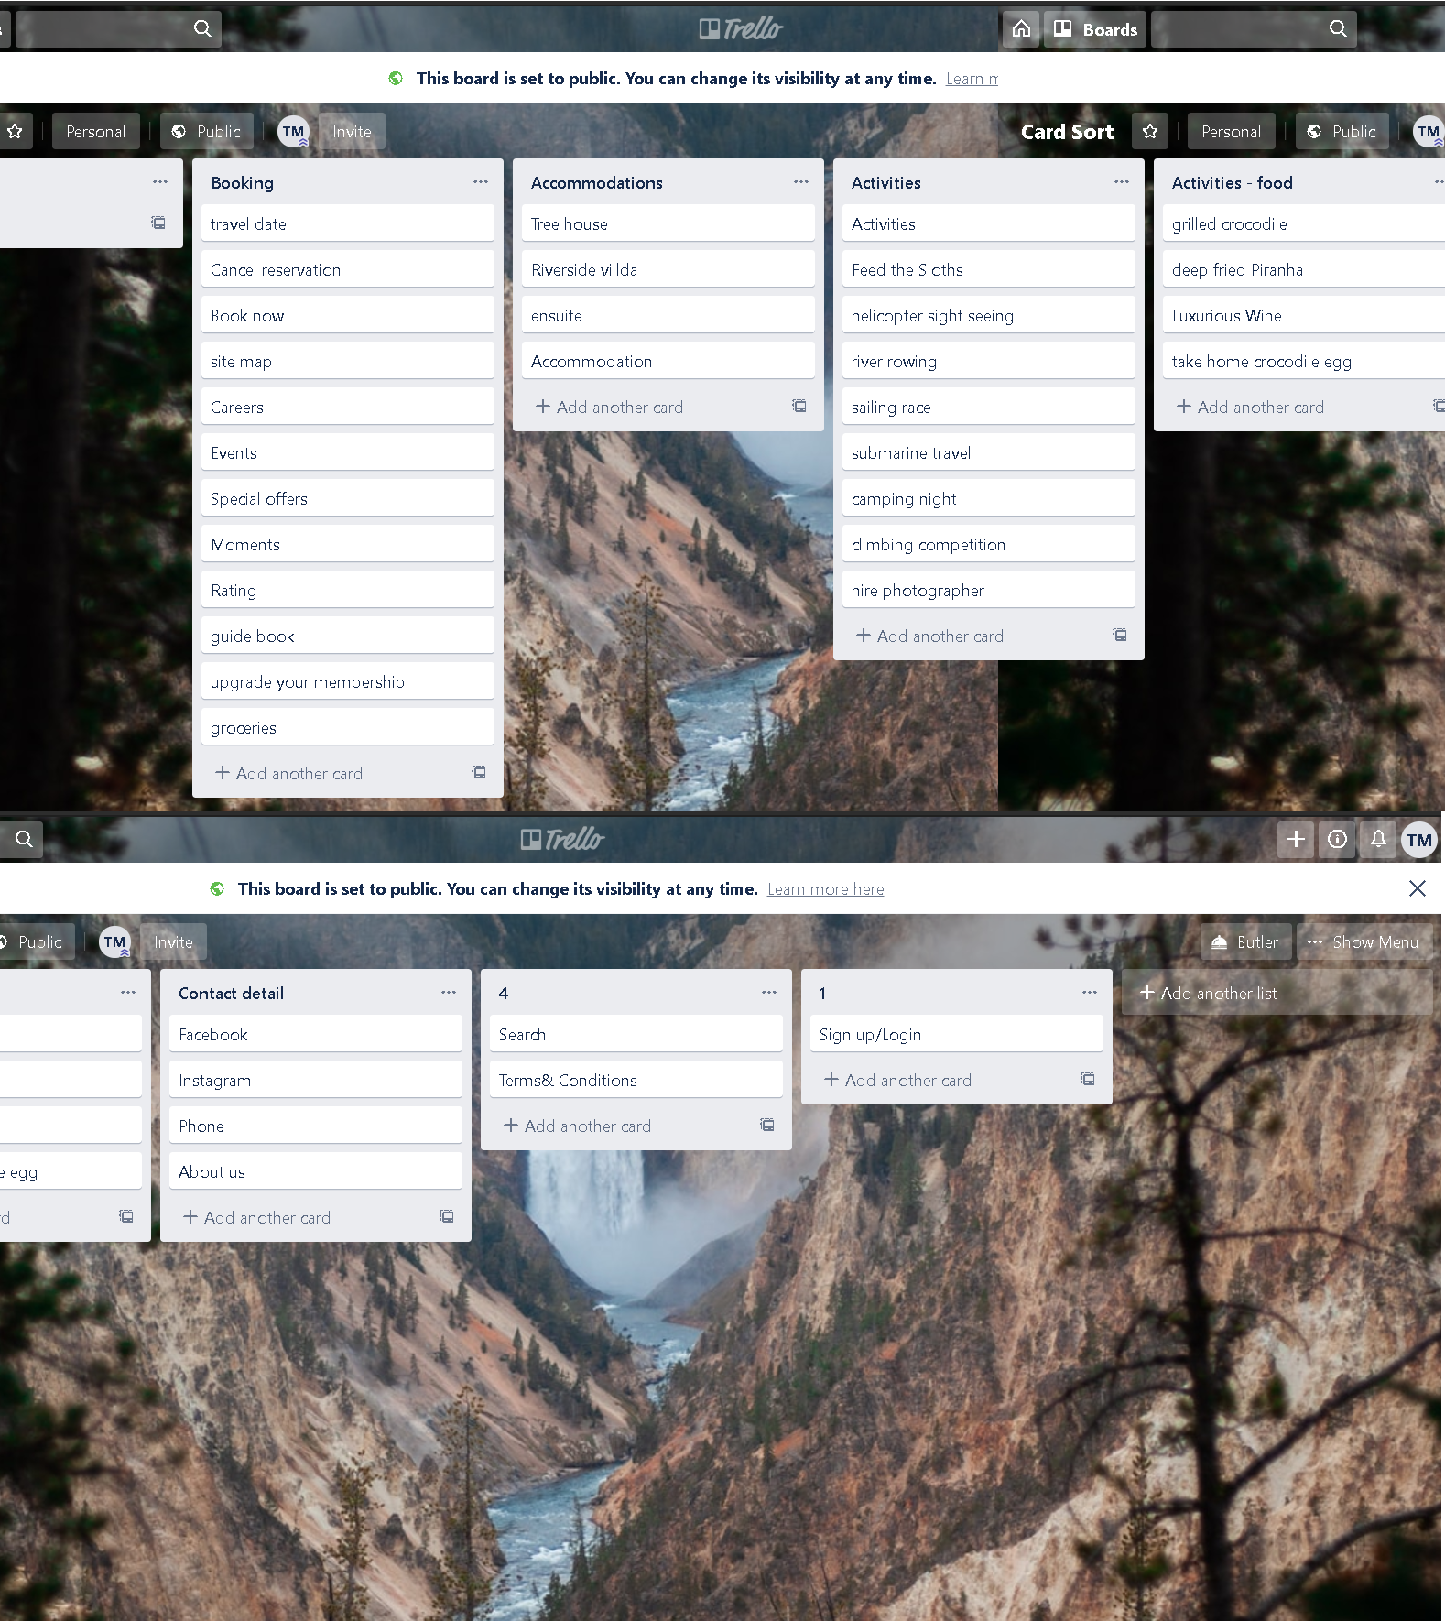

The “Booking” contains most of the activities about reservation and information. There were some unexpected yet interesting decisions. The cards ‘events’, ‘moments’ are chosen to be in “Booking” section, according to the user was because he thought that customer may want to look at some photos or moments about the resort and then decide which one to book. The card ‘rating’ was also in this section since customer want to rate the resort after the book and enjoy their vacation. Thus, the ‘rating’ is reasonably put in “Booking”. Other cards like ‘groceries’ or ‘Careers’ are also chosen as the ‘user’ felt it is quite related to the booking action. Other sections were put appropriately since their properties clearly told their categories.

The second user witnessed the first user’s sorting process. Therefore, he came up with a more convincing result. There were 8 groups, Accommodations, Membership, Contact detail, Activities – Guide, Activities – food, Activities – explore, Activities – special, Booking and an unnamed group.

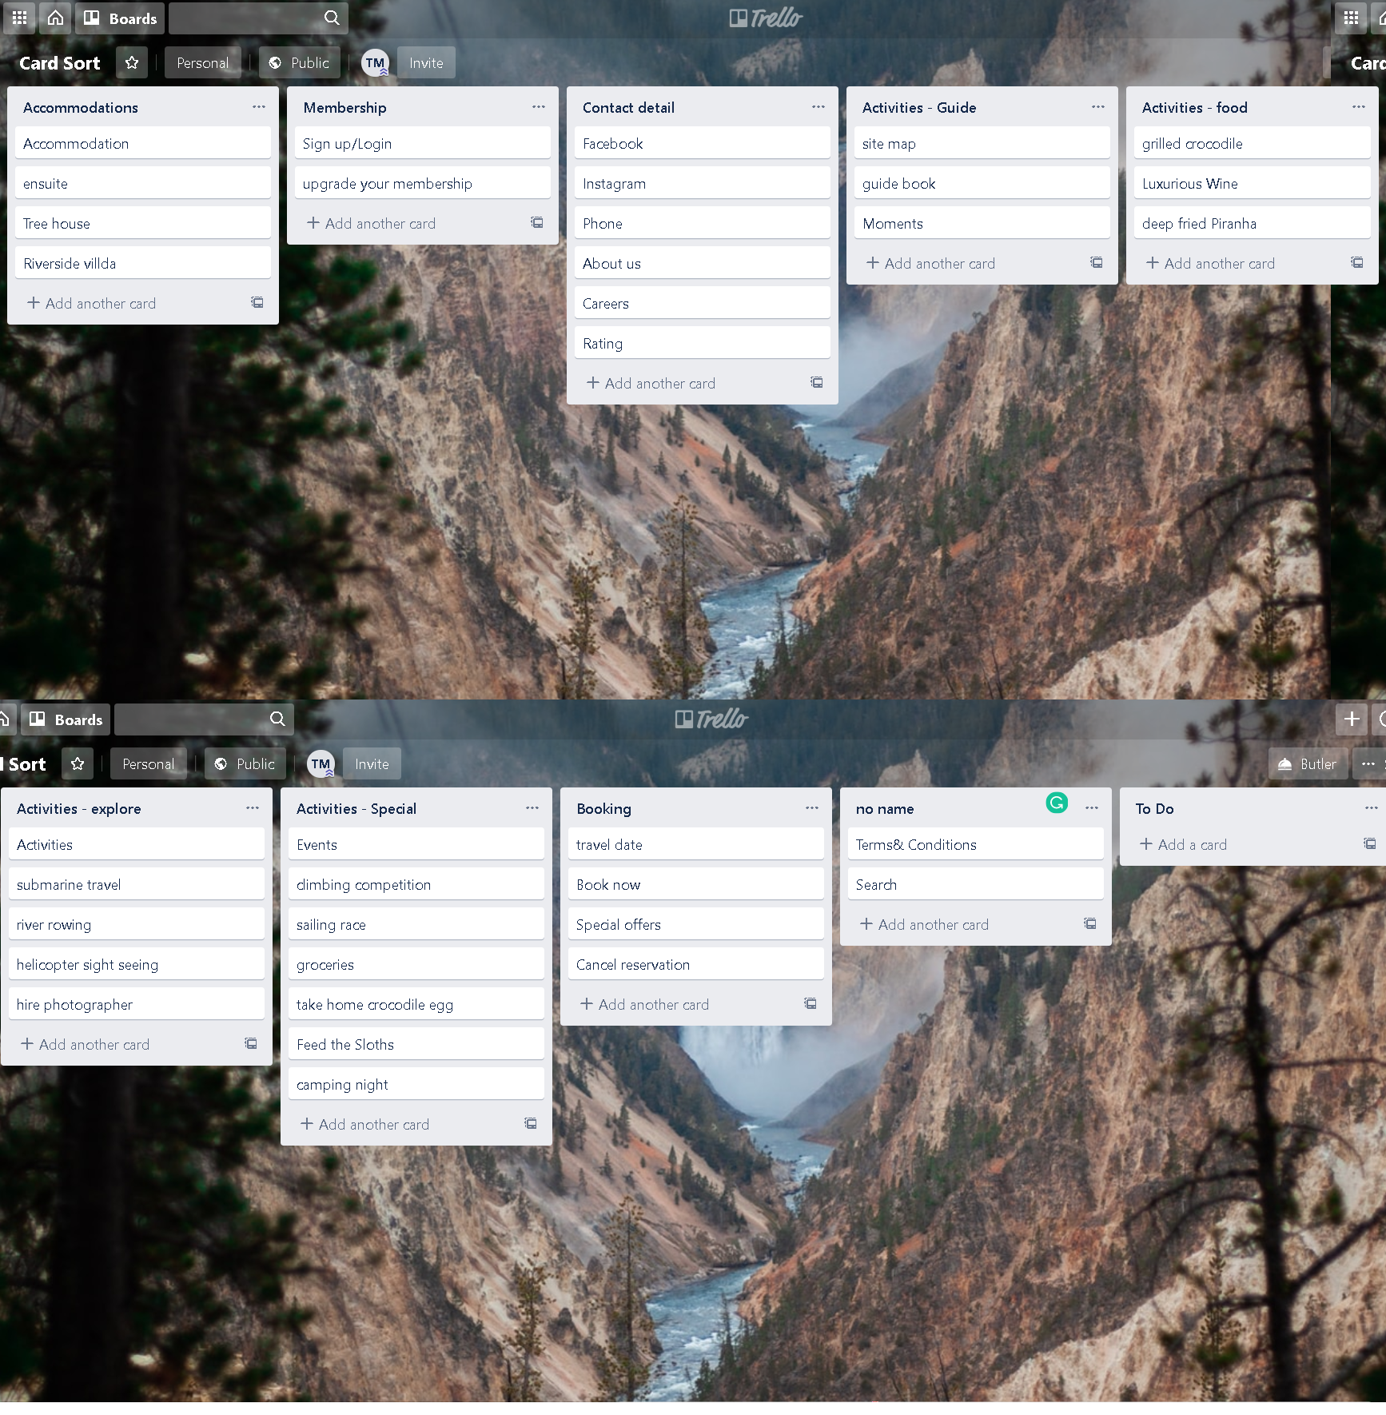

What is different from the first model is that more cards were put in a more organised way. The section Activities – Guide, Activities – food, Activities – explore, Activities – special are actually a sub-section of Activities as they are all the things the customers can do at the resort.

One same problem in both models is that the cards ‘Terms&Conditions’ and ‘Search’ could not be given an appropriate name. The users a thought that they should be stands alone with their own name on the webpage. For example, the ‘Terms&Conditions’ should be at the bottom of the page and the ‘Search’ might be on the top-right corner as this is common in most websites.

I decided to take the second user’s model for my content since the way it is organised is very clear and appropriate and the name given to the groups are also persuasive.

# Navigation & Organisation Systems

In the “Navigation Systems” table discussion, two examples were brought by the leader to evaluate how effective the two’s navigation systems is. One is an example of good navigation system and one is an example of bad one.

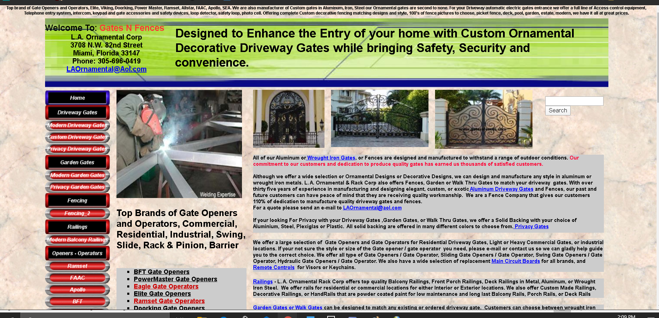The website Gatesnfences (n.d.) is an example of bad navigation system.

The website use primary navigation, but the part is put on the left side instead of putting on top of the page as usual. The current site where the user is at is made blue border. There is also local navigation in the website, which does not look really good either. Since the website has an unusual navigation system, it might make users confused how to navigate around the website. The way the menu organize headers and sub-contents is also terrible and unattractive.

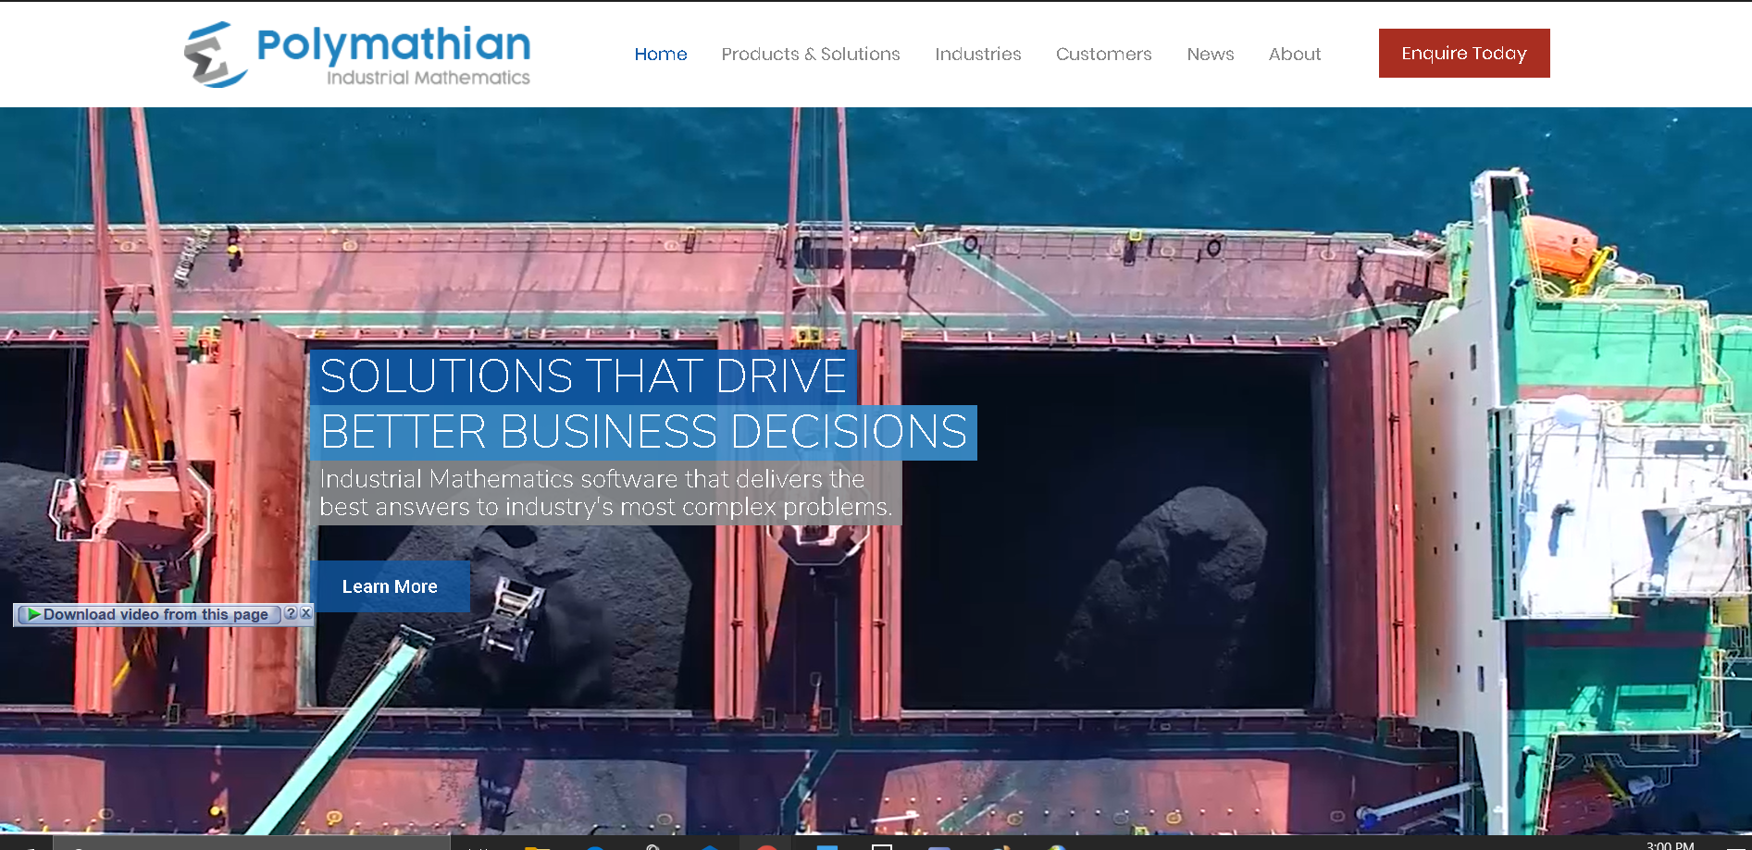The example for good website is Polymathian (n.d.).

The website’s navigation system is very well organized and clear. Website use primary navigation at the top. Each navigation header is a drop-down list that contain other sub-sections, each section is named and grouped appropriately. There are also supplementary navigation, local navigation and footer navigation which is decorated very well and attractive.

After the table discussion, I learn some fundamental point about making a navigation system. Firstly, it is best to try making the navigation as succinct as possible, but still explicit enough to understand. Too many words or cumbersome content can make the website look worse and confusing. The user might find it hard to look for their destination. Secondly, icons can help sometimes. Using icons instead of words can make the navigation more attractive, since people often find it easier to recognize a picture than read some words. Another point that cannot be ignored is the effect. Overusing effect or underusing effect might make the website messy or boring. The users therefore will not like to visit the website. Thus, interactive effect being apply in appropriate way might help the website attract more users.

# Site Map & Content Architecture

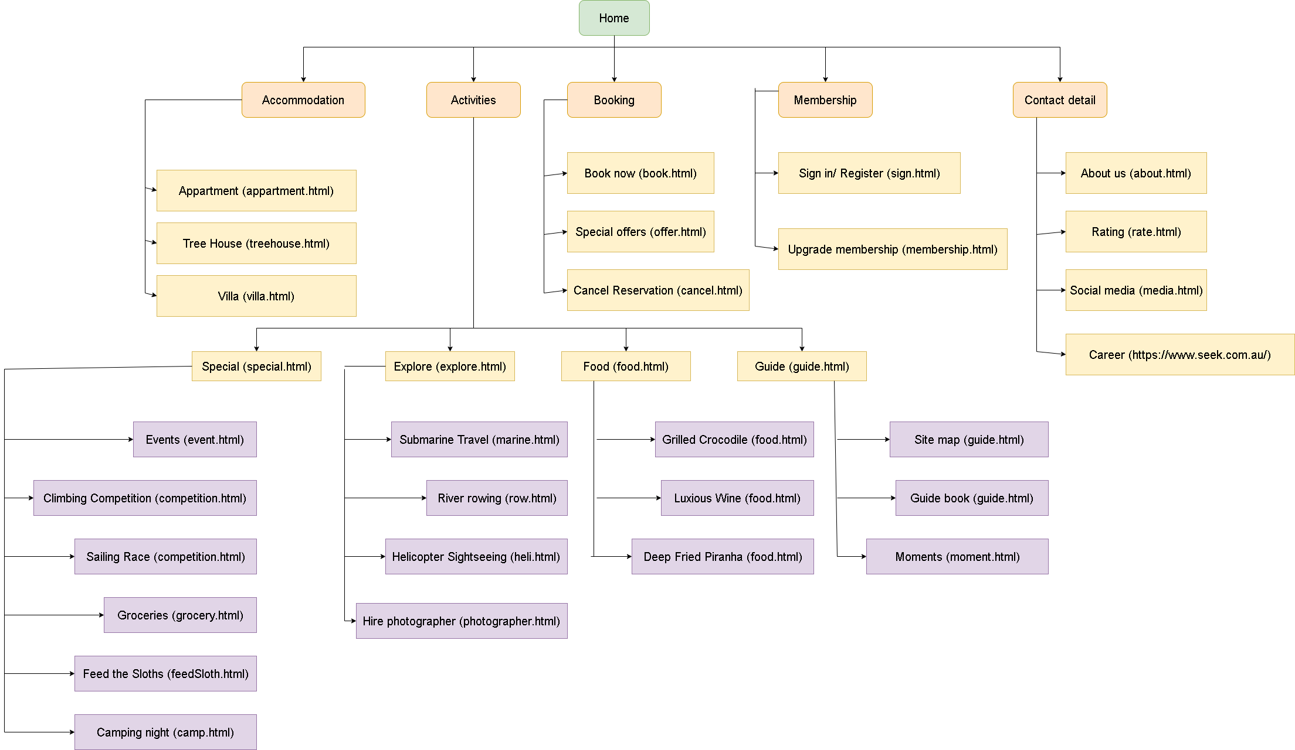After considering the examples from table discussion, I came up with the follow site map which I think should make good navigation.

This is a primary navigation system. As at home page, there will be navigation to other sites, Accommodation, Activities, Booking, Membership and Contact detail. These navigation headers, in orange, are drop down list which will show the sites that user can go to (in yellow). The activities site is a big section. Therefore, there are other sub-section (in purple) which will show user a brief of some tipical content or site that user can find in the section.

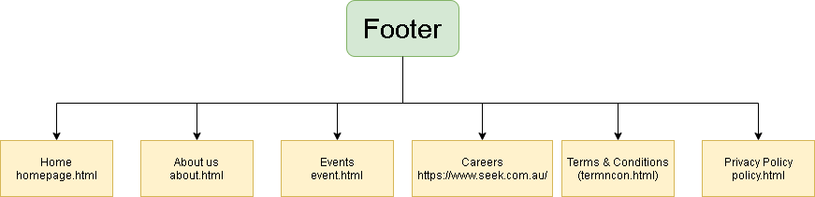

The footer of the page also has navigation with the same colour meaning.

# Visual Organisation & Interactivity

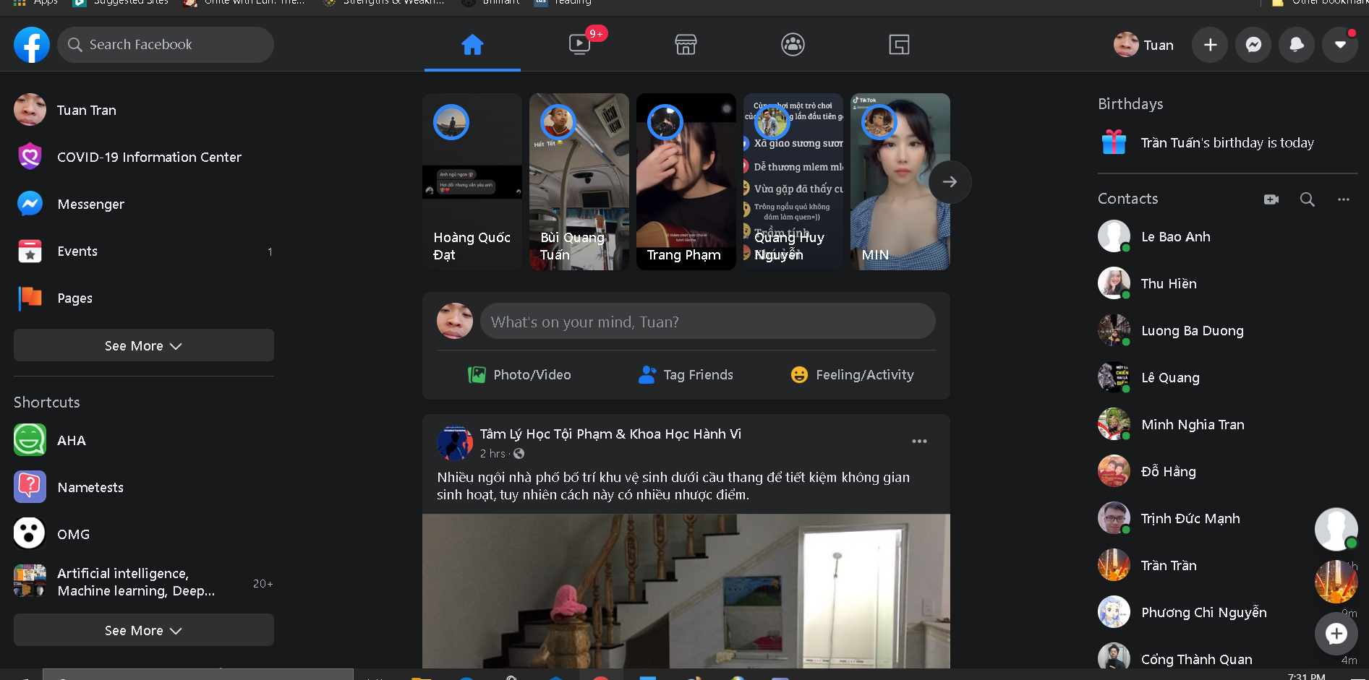The website that was taken as example for this “Visual Organisation” table discussion was Facebook (n.d.).

Facebook has a simple but eye-catching layout. Wordings and icons are implemented very well that users can easily ‘travel’ around the website without hardships. As Facebook is a social network website, the main content is to show users what is happening around them and what other users are doing. Therefore, the newsfeed content is made big and standing out enough for the users to recognise what they need to focus on this website. The website probably has a wide range of target audience, since the interactive elements are made simple but still flashy enough that most people will find it fairly attractive.

There is a clear division between the sections in the websites. As can be seen, Facebook explicitly divides the site into three part vertically, with big space in between. The sub-sections in each section are also divided by horizontal lines or spaces. Users can clearly distinguish the sections without confusion. Hence, the proximity of the website is well implemented.

The website also has a consistent elements aligning. Words are well readable with left alignment. Each article has a clear header and contents, buttons for comment, sharing and like also divided equally. This make the website look professional. It is enjoying when surf through the website and read other people’s newsfeed. The page is also divided vertically by grids. The main content in middle take approximately 4 grids while two side contents each have two grids; the remaining is for delimiter between three sections. By grids division, we can see that Facebook page has a good balancing, which is designed symmetrically.

The website’s newsfeed is made double the two side contents so that it can draw more attention from users, since this is the main content of the website. Headers and buttons are also made interactive and standing out so that users can recognize the difference between sections and elements. Word’s colors are also implemented well so that key words can be emphasized which help user grasp the content’s idea more easily. There is also a contrast between background and font color (black in background and white color for words). This make the content more readable and approachable.

Facebook also has a good consitency. Each type of content agree with the same styling. This make the elements more related to each other, page’s content is jointed well.

After the table discussion, there were some change of my mind to my website design. As I learnt that dividing the website by grids make the website more organized and consistent, I also add grids for my design. The contents are divided by a proportional, which makes the page look significantly nicer. Moreover, the contrast helps contents more readable. Hence, I increase the contrast between background and content font color. Another point to improve is that the website looks better when it has a good balance. Therefore, instead of making my design mostly aligned to the left like before, I decided to make it symmetrical as I reck on that it looks way better.

# Paper Prototype User Testing

An Invision (n.d.) prototype was prepared for the User Testing Activity. There were five tasks for ‘users’ to do while their reactions and comments are noted. The five tasks are Register/ Log in, Book a Treehouse Accommodation, Make Payment, Cancel Reservation and Book a Helicopter Sight-seeing Tour.

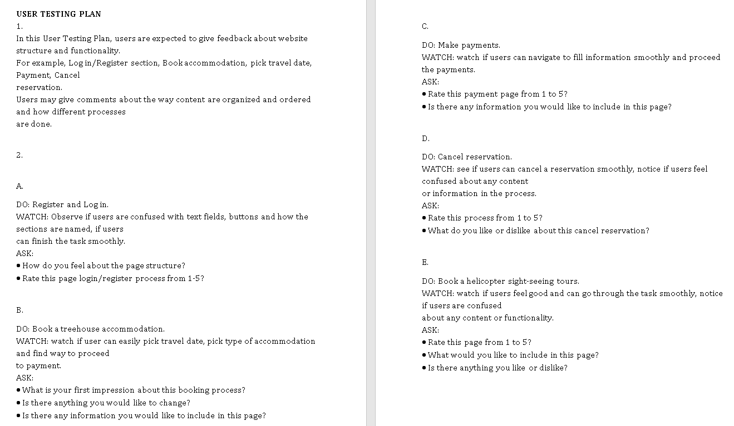

Testing plan followed the Week 4 tutorial outlines to create appropriate test for users. Users then are asked to rate the process, the page structure and give comment about any things they did not like or feel confused about.

Webpage prototype was created by Invision(n.d.). The pages’ structure was referred to the original webpage design idea.

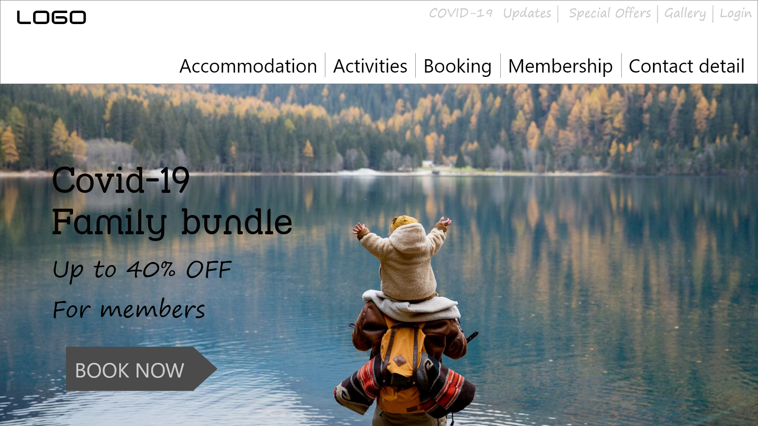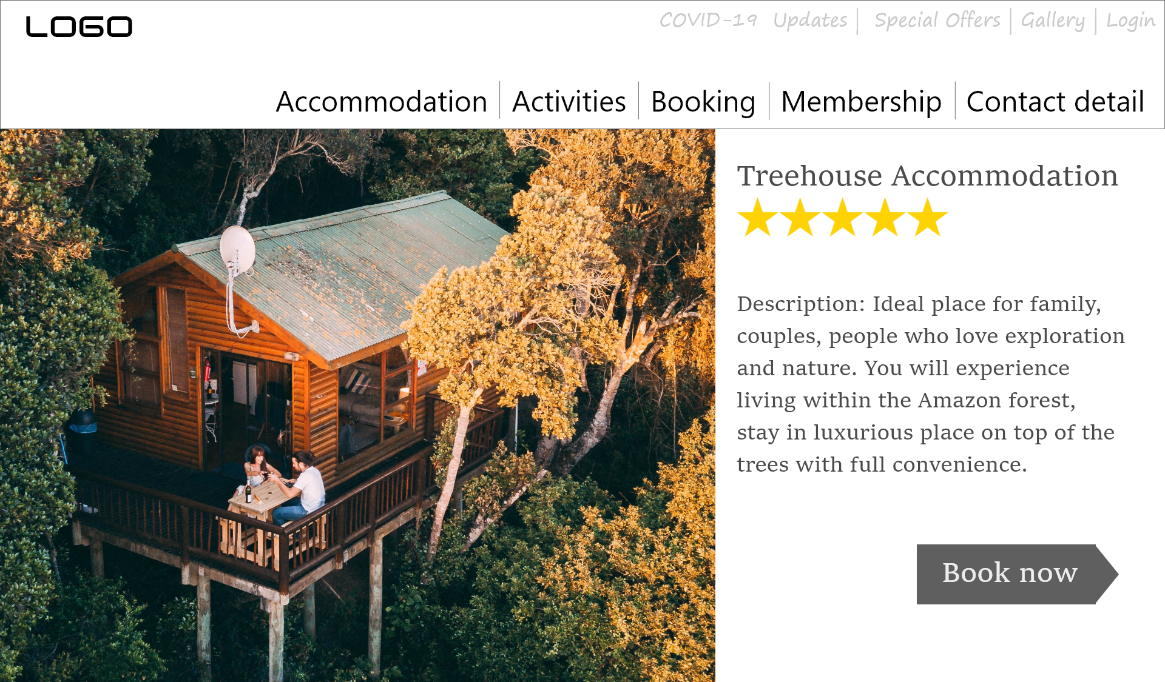

Website prototype (Invision, n.d.)

In the activity, the prototype was presented on my device. Then, users would come and give instruction what and where they want to click or move to. Questions about their reason and thinking were given while users were giving the instructions. Subsequently, when all tasks are done, users were asked to given an overall rating for the website and point out things they liked or did not like.

There were two users that finished this prototype test. Generally, the tasks were done smoothly. Both users did not show any confusion while navigating through the website. It was said that it was quite easy for them to figure out where to find what they want. Navigating throughout the website to know where to find Treehouse, cancel booking or find login section was fairly explicit. For examples, Treehouse can be found in Accommodation, to cancel booking go to Booking on navigating menu and login section is shown on the sub-top-menu.

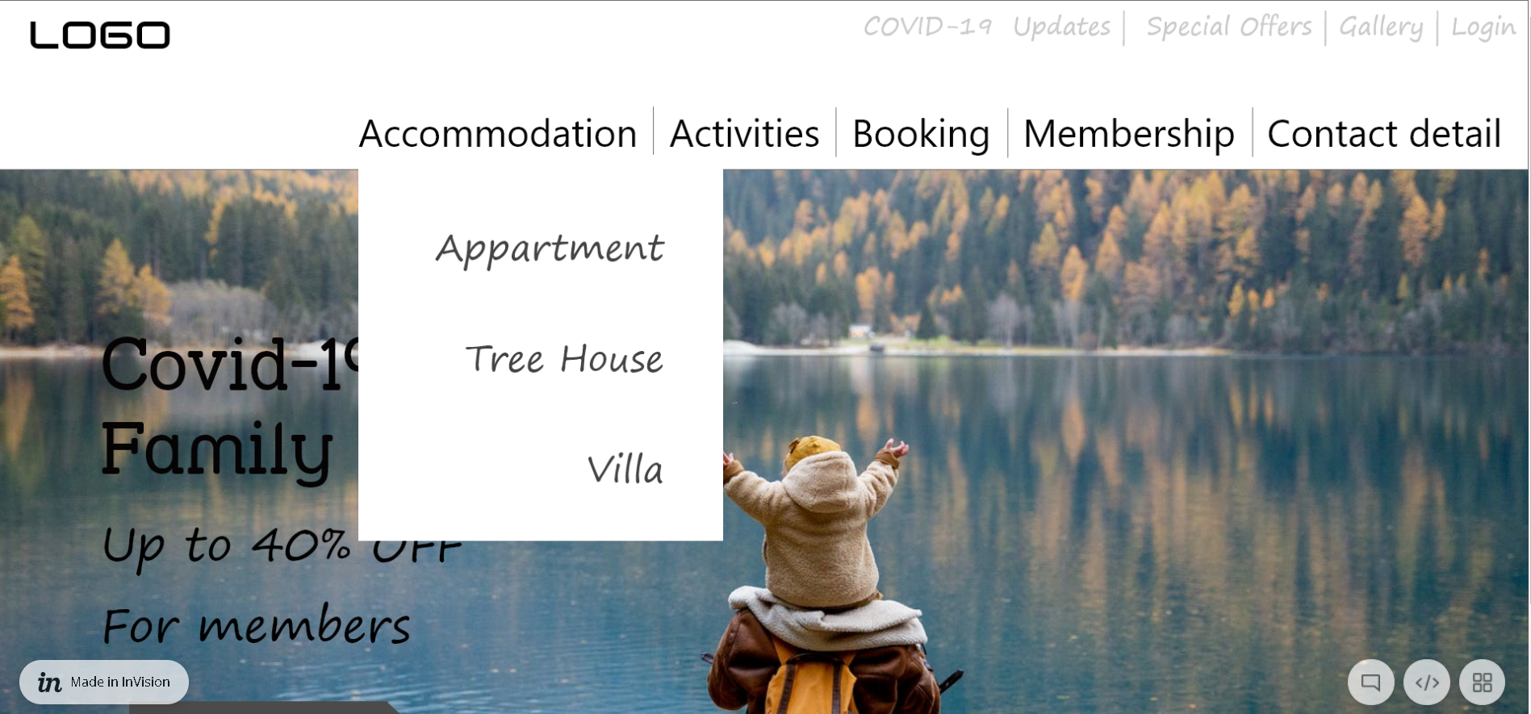

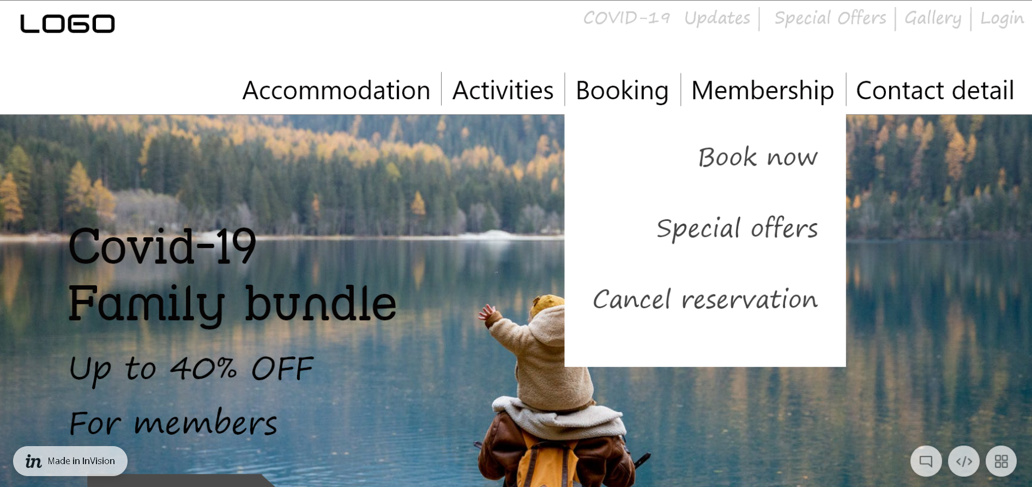

Website prototype, Homepage

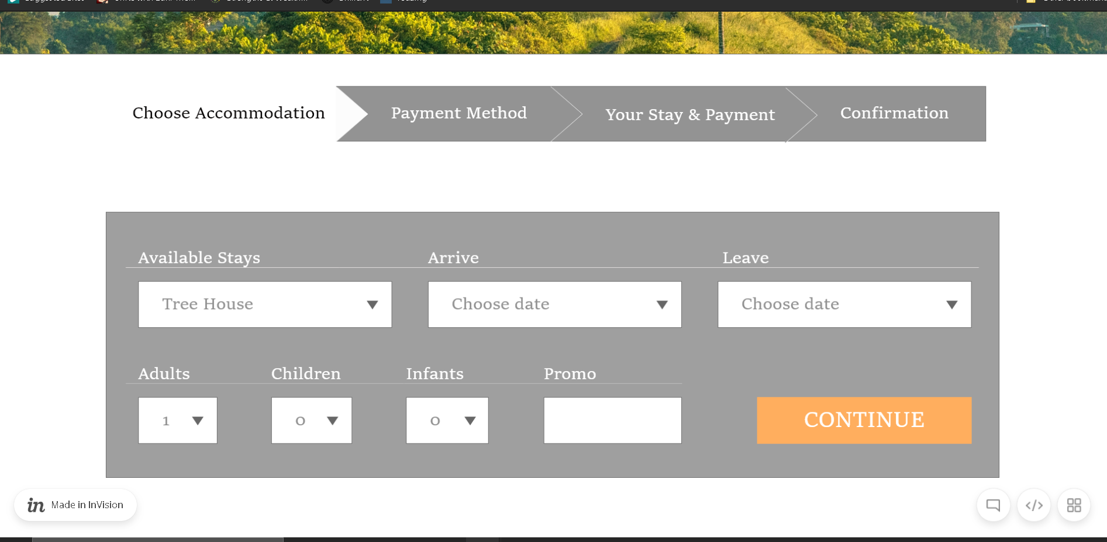

Website prototype, Booking process

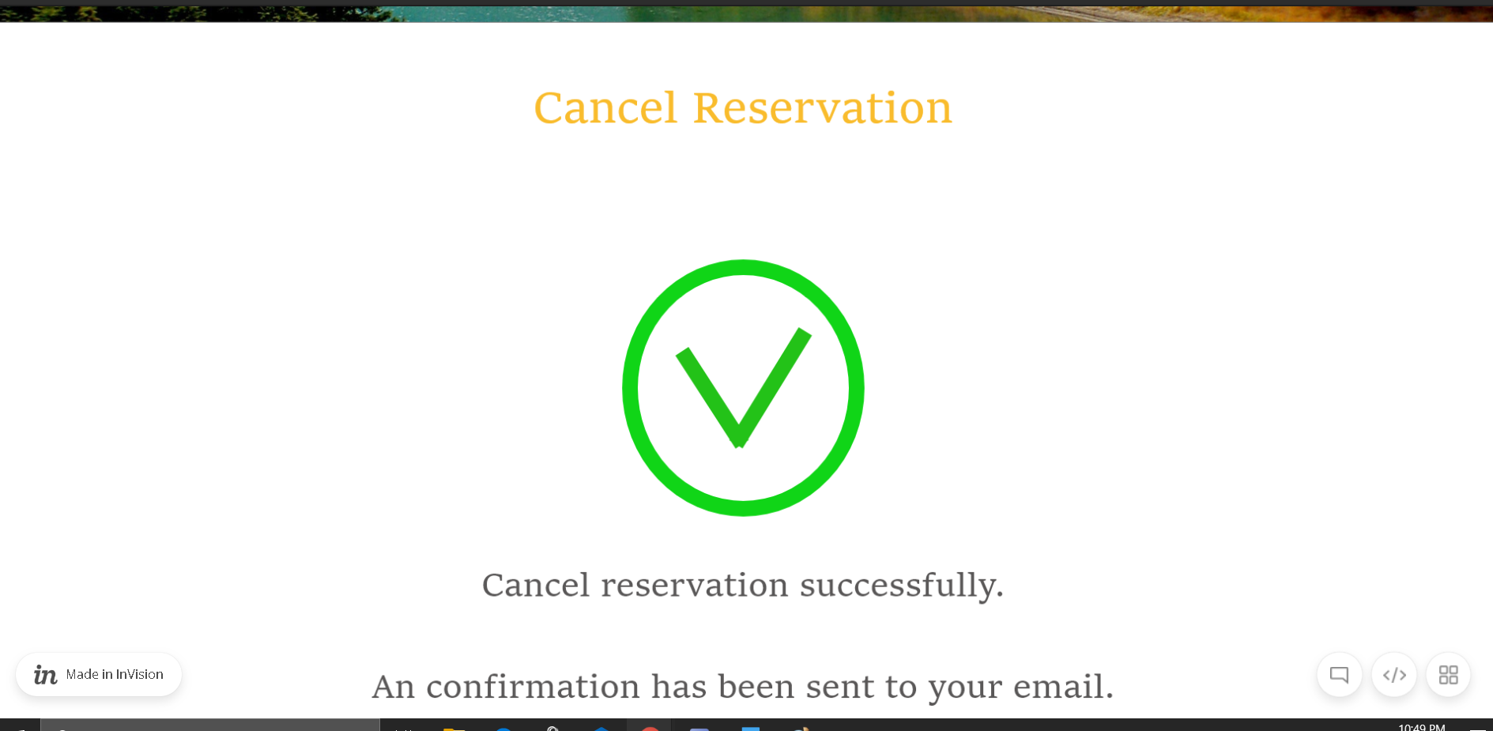

Website prototype, Cancel reservation process

The navigation and functionality were highly appreciated. However, few points that users feel bad about the visual organisation was proposed. Firstly, one of the users claimed to be quite confused when finding the login section. The reason was that the login button which located on the top menu was a little ambiguous since its size and color was similar to other neighbors. Therefore, this user preferred to make the login button bigger or change its color to make it more visible.

Another bad point was that the list to be appear from the element Activities on the main navigation menu was too verbose.

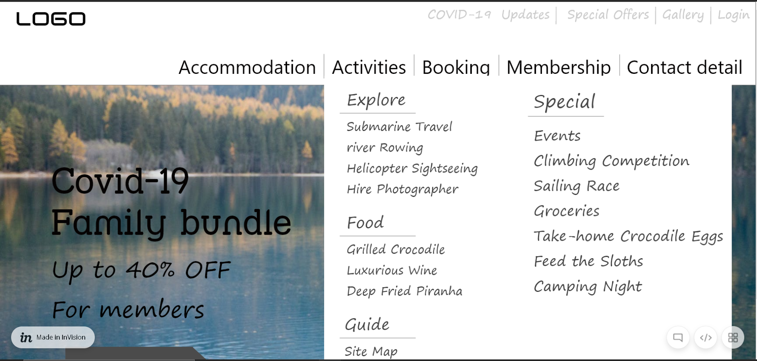

One suggestion from the user is that the drop-down list should only be showing the header of the content only. Which mean the content should contain only Explore, Special, Food and Guide. Subsequently, the detail might be put to another page or a sub-dropdown list from the headers.

One more remark from the user was about the typo in the Cancel booking task.

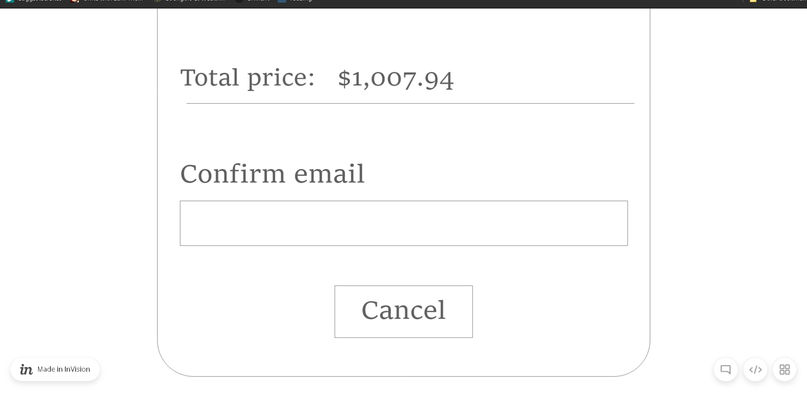

The cancel button in the Cancel booking process was meant to confirm the cancelling. However, this make a confusion for the users that it might be cancel this Cancel booking as well. “Submit” or “Process” would be a better choice for this situation.

Overall, users seemed satisfied with the functionality and navigation of the website. However, there a need for the visual organization to be fixed. Users’ experience is important that can decide whether the website would survive or not. Therefore, appropriate changes then shall be applied to the website design.

Part B

Aesthetics

*This section relates to the “Aesthetics Prototype User Testing” design activity.*

***Suggested length:*** *3 pages*

***What’s your general aesthetic?****Visually present aesthetics mockups for 3 types of pages on your website (e.g. home page, information page, product page). What’s your intentions?*

*Add annotations relating to design principles from the lectures to describe:*

* *The colour scheme you used (including HEX/RGB codes);*
* *The typographic hierarchy you used (including font names, sizes, weights etc);*
* *The button/link treatments (e.g. hovering on a link);*
* *How the aesthetic engages your specific target audience.*

***What feedback did you get from the Aesthetics Prototype User Testing design activity?****Include screenshots of the feedback you received from the design activity. Reflect on how the feedback has informed your aesthetics decisions.*

***What did you learn from the Aesthetics table discussion?*** *Describe 3 new things that you learned from the table discussion. Which of your design choices do you think differently about after the table discussion and why?*

https://www.carolinaherrera.com/au/en/

https://www.engvid.com/

Technical Implementation

*This section relates to the “Accessibility, Graceful Degradation & Progressive Enhancement” table discussions.*

***Suggested length:*** *2 pages*

***How will you implement your interactions?****Create a table, where each row is an interaction, and describe how you will use a combination of HTML, CSS and JavaScript to implement them.*

*Consider the following:*

* *Justify why each interaction is meaningful.*
* *Will you use a JavaScript plugin or code certain features in JavaScript yourself?*
* *How will you incorporate progressive enhancement in your code?*
* *How will you ensure your website is accessible?*

***What did you learn from the Accessibility, Graceful Degradation & Progressive Enhancement table discussions?*** *Describe 3 new things that you learned from the table discussions. Which of your implementation choices do you think differently about after the table discussion and why?*

https://splendourinthegrass.com/

https://www.ebay.com.au/

wikipedia

Final Feedback

# Hi-Fi Prototype User Testing

*This section relates to the “Navigation Systems” table discussion.*

***Suggested length:*** *2 pages*

***What did you prepare for the Hi-Fi Prototype User Testing design activity?****Include screenshots of the testing plan you developed for the design activity. Refer to the Week 13 tutorial outline for what to include in your testing plan.*

***What feedback did you get from the Hi-Fi Prototype User Testing design activity?****Include screenshots of the feedback you received from the design activity. Also include photos of the design activity running. Reflect on how the feedback has informed your final implementation decisions.*

Contact detail - > About us

Social media - > Contact detail

Conclusion

***Suggested length:*** *½ page*

***Do you consider your final website a success?*** *Describe why you feel your final website has been a success or not a success. How would you respond to the brief differently if given another chance/more time?*

***How has your learning strategy changed?*** *Reflect on how your learning strategy has changed since you started the design process (referring to “Introducing the Web Designer” earlier in the report). If you had a chance to start again, how would you approach your learning differently?*

References

Brown wooden house surrounded by trees [Image] (n.d.). Retrieved from <https://www.pexels.com/photo/brown-wooden-house-surrounded-by-trees-3889919/>

DC Comic (n.d.). Retrieved from <https://www.dccomics.com/>

Facebook (n.d.). Retrieved from <https://www.facebook.com/>

Gatesnfences (n.d.). Retrieved from <http://www.gatesnfences.com/>

Invision (n.d.). Retrieved from <https://invis.io/XHWPTMAQT4M>

Lizard Island (n.d.). Retrieved from <https://www.lizardisland.com.au/>

Marvel Comic (n.d.). Retrieved from <https://www.marvel.com/comics>

Outdoor Navigation Für Wanderer [Image] (n.d.). Retrieved from <https://www.pinclipart.com/pindetail/moimm_outdoor-navigation-fr-wanderer-map-clipart/>

Polymathian (n.d.). Retrieved from <https://polymathian.com/>

Responding Clipart [Image] (n.d.). Retrieved from <https://www.pinclipart.com/pindetail/iThxwx_j0442108-responding-clipart-png-download/>

Trello (n.d.). Retrieved from <https://trello.com/>

Writer's Reference Center [Image] (n.d.). Retrieved from <https://www.pinclipart.com/pindetail/bwhwbx_writers-reference-center-reference-clipart-png-transparent-png/>

Xtensio (n.d.). Retrieved from <https://xtensio.com/user-persona/>